 | No.LS412-001  06 JanuaryJanuary 2006
   | Technical Service BulletinTechnical Service Bulletin

Subject/ConcernSubject/Concern: | Range Rover Sport - Omission of Fuel-Fired Booster Heater

ModelsModels:
Range Rover Sport (LS) |  | Diesel engine derivatives | Diesel engine derivatives Vin rangerange: 5A90506-5A904584

MarketsMarkets: | Canary Isles, Cyprus, France, Gibraltar, Italy, Malta, Morocco, Portugal, Spain, Turkey and UK only.

SectionSection: | 412-02B

SummarySummary:
A customer may report a concern that in cold conditions the cabin is slow to warm up and that heater performance is generally poor, or that the auxiliary fuel-fired booster heater is not working.
CauseCause: | The vehicle has not been installed with an auxiliary fuel-fired booster heater (FFBH) due to a specification error during build.

ActionAction: | On a customer complaint basis only, refer to the Service Procedure detailed in this bulletin to retro-install the auxiliary heater.

Parts RequiredParts Required:
DescriptionDescription | Part NumberPart Number | QuantityQuantity
Fuel pump cover (access flange) | WGC500044 | 1
Fuel line – FFBH pump to FFBH | WJP500385 | 1
Clip | KYC500020 | 7
Fuel line – FFBH pump to tank | WFP500078 | 1
FFBH fuel pump and filter | JEX000043 | 1
Screw | FS106257L | 3
FFBH assembly | JEC500790 | 1
Muffler | JEZ500050 | 1
Screw | FS106127L | 2
Nut | AWR6715 | 2
Hose Assembly – FFBH to heater | JHB500822 | 1
FFBH pump harness kit | YNI500420 | 1
Fuel Pump Module | WGS500071 | 1
Seal (Gasket) | WGQ000031 | 1
Adhesive Pad | WFK500011 | 1
Hose Clip | WYC100780L | 1
NOTENOTE: Claims must be submitted using the appropriate parts shortage code.
Labour TimeLabour Time:
Operation DescriptionOperation Description | Operation No.Operation No. | TimeTime
Retro install fuel burn heater feature | 80.40.89/29 | 4.80 hours

Repair/Claim CodingRepair/Claim Coding:
Causal PartCausal Part: | JEC500790
ACES Condition CodeACES Condition Code: | 39
Defect CodeDefect Code:

Service ProcedureService Procedure
11 . | Remove the fuel tank module. For additional information, refer to Global Technical Reference (GTR) For additional information, refer to Global Technical Reference (GTR) Range Rover Sport Workshop Manual SectionWorkshop Manual Section 310-01C, Fuel Pump Module (19.45.03).

22 . | Remove the cooling fan lower shroud and fan assembly. For additional information, refer to Global Technical Reference (GTR) For additional information, refer to Global Technical Reference (GTR) Range Rover Sport Workshop Manual SectionWorkshop Manual Section 303-03C, Cooling Fan Shroud (26.25.11).

33 . | Drain the cooling system. For additional information, refer to Global Technical Reference (GTR) For additional information, refer to Global Technical Reference (GTR) Range Rover Sport Workshop Manual SectionWorkshop Manual Section 303-03C, Cooling Fan Draining, Filling and Bleeding (26.10.01).

44 . | Release the power steering fluid reservoir and position aside.
 | 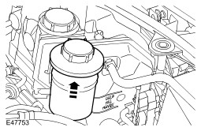

55 . | Remove the right-hand fender splash shield.

66 . | Remove the exhaust system.

77 . | Remove the front left-hand fender splash shield.

88 . | Remove the exhaust heat shield retaining nut.
 | 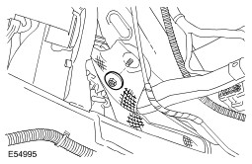

99 . | Remove the upper suspension arm and brake line heat shields for access.
 | 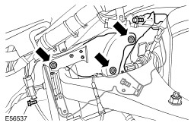

1010 . | Remove the exhaust heat shield:
  11 . | Remove the two retaining nuts.
  22 . | Remove the retaining bolt.
 | 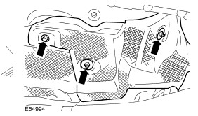
Install
1111 . | Install the new fuel pump module. For additional information, refer to Global Technical Reference (GTR) For additional information, refer to Global Technical Reference (GTR) Range Rover Sport Workshop Manual SectionWorkshop Manual Section 310-01C, Fuel Pump Module (19.45.03).

1212 . | Prepare the 8-way electrical connector for fuel-burning heater overlay harness:
  11 . | Release the 8-way electrical connector.
  22 . | Slide the red connector latch to one side.
  33 . | Disconnect the electrical connector.
  44 . | Remove the blanking plug from the connector as shown.
  55 . | Release the white anti-backout to the detent position.
 | 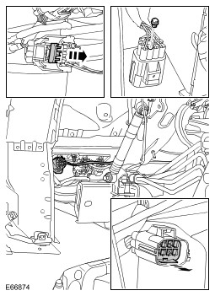

1313 . | Connect the overlay harness to the electrical system:
  11 . | Position the connector pin into the receptacle as shown, and secure the anti-backout clip.
  22 . | Connect the ground lead to the wheelarch ground stud.
 | 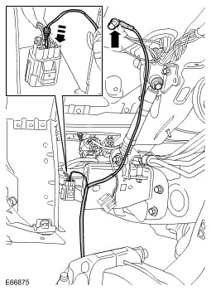

1414 . | With care, route the overlay harness and secure with cable ties 50mm from the electrical connector and every 150mm.
 | 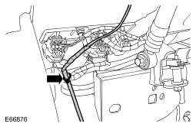

1515 . | Install the fuel-fired booster heater line following the route of the engine fuel supply lines. Secure the line as necessary with the twelve pipe clips.
 | 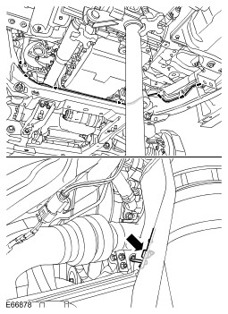

1616 . | Install the fuel-fired booster heater auxiliary pump:
  11 . | Install the bolt and tighten to 10Nm (7lb-ft).
  22 . | Connect the electrical connector.
  33 . | Connect the two fuel lines.
  44 . | Secure with the clips.
 | 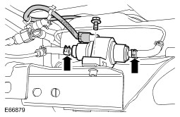

1717 . | Connect the fuel-fired booster heater supply hose to the heater matrix return line:
  11 . | Release the clip and disconnect the hose.
  22 . | Connect the new hose and secure with clip.
 | 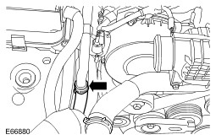

1818 . | Connect the fuel-fired booster heater return hose to the cylinder head coolant 'T' piece:
  11 . | Release clip and remove original coolant loop hose.
  22 . | Connect the new hose and secure with clip.
 | 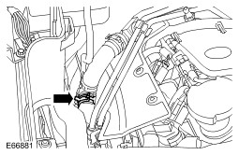

1919 . | Route the fuel-burning heater hoses as shown:
  11 . | Secure with 2 cable ties.
  22 . | Secure with the new clip.
 | 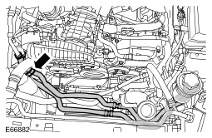

2020 . | Install the fuel-fired booster heater exhaust bracket and tighten the bolt to 10Nm (7lb-ft).

2121 . | Install the fuel-burning heater:
  11 . | Tighten the bolts to 10Nm (7lb-ft).
  22 . | Connect the electrical connectors.
  33 . | Secure the fuel pipe in the clip.
 | 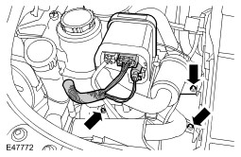

2222 . | Connect the fuel-fired booster heater fuel hose and secure with the clip.

2323 . | Connect the fuel-fired booster heater coolant hoses to the heater and secure with the two clips.
 | 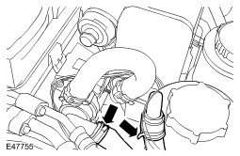

2424 . | Install the fuel-fired booster heater silencer:
  11 . | Clean the component mating faces.
  22 . | Tighten the bolt to 10Nm (7lb-ft).
  33 . | Tighten the clamp nut to 10Nm (7lb-ft).

2525 . | Install the fuel-fired booster heater exhaust pipe:
  11 . | Clean the component mating faces.
  22 . | Tighten the clamp nut to 10Nm (7lb-ft).
 | 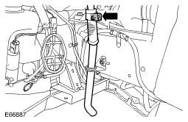

2626 . | Install the heat shields to the upper suspension arm and brake lines.

2727 . | Install the exhaust heat shield and tighten the retaining nut to 10Nm (7lb-ft).

2828 . | Install the differential mounting bracket heat shield and tighten the retaining nut to 10Nm (7lb-ft).

2929 . | Install the exhaust system.

3030 . | Install both front fender splash shields.

3131 . | Install the power steering fluid reservoir.

3232 . | Install the cooling fan assembly. For additional information, refer to Global Technical Reference (GTR) For additional information, refer to Global Technical Reference (GTR) Range Rover Sport Workshop Manual SectionWorkshop Manual Section 303-03C, Cooling Fan (26.25.19).

3333 . | Install the cooling fan lower shroud. For additional information, refer to Global Technical Reference (GTR) For additional information, refer to Global Technical Reference (GTR) Range Rover Sport Workshop Manual SectionWorkshop Manual Section 303-03C, Cooling Fan Shroud (26.25.11).

3434 . | Refill and bleed the cooling system. For additional information, refer to Global Technical Reference (GTR) For additional information, refer to Global Technical Reference (GTR) Range Rover Sport Workshop Manual SectionWorkshop Manual Section 303-03C, Cooling Fan Draining, Filling and Bleeding (26.10.01).

3535 . | Connect the battery ground cable.

3636 . | Connect WDS to the vehicle.

3737 . | Select the 'Current Vehicle Configuration' tab (top left corner of the screen).

3838 . | Select the 'Engineering Mode' tab (grey 'key' right-hand side of the screen).

3939 . | A screen with 'Enter Password' will appear. Contact local support; provide the last six digits of the VIN and the 'seed code' displayed.

4040 . | Enter the engineering code supplied by local dealer network support and select the green tick (bottom right-hand corner of the screen).

4141 . | The vehicle configuration file can now be edited:
  11 . | Locate the list entry under the heading 'Climate Control System' for the 'Auxiliary Heater'.
  22 . | In the options, change the item to reflect that the FFBH is now installed.

4242 . | Remove WDS from the vehicle.
©2006 LandRover

